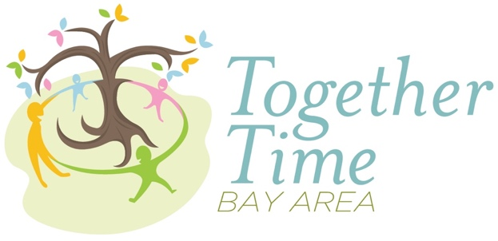
Sally Fraser
Professional Provider Supervised Visitation
www.togethertimebayarea.com
sally@togethertimebayarea.com
510-295-8041
Intake Information

Date: _____________________________________________________________________

Who has physical custody? ____________________________________________________

Who has legal custody? _______________________________________________________

Your Full Name: _____________________________________________________________

Address: ___________________________________________________________________

Mobile Phone: _______________________________________________________________

Secondary phone if applicable: __________________________________________________

Email: ______________________________________________________________________

Other Parent’s Full Name: ______________________________________________________

Child’s Full Name, Nickname, Age, Date of Birth: _____________________________________

Child’s Full Name, Nickname, Age, Date of Birth: ______________________________________

Child’s Full Name, Nickname, Age, Date of Birth: ______________________________________

Emergency Contact

Name: _____________________________________________________________________

Relationship to you: ___________________________________________________________

Mobile Phone: _______________________________________________________________

Secondary phone if applicable: __________________________________________________

Your Attorney Information

Name: ______________________________________________________________________

Email: _______________________________________________________________________

Phone: ______________________________________________________________________

Permission for this provider to communicate with attorney by voice and/or in writing? _________

Custodial Parent
Please email or text one photo of each child to sally@togethertimebayarea.com or 510-295-8041.
(Multiple children can be combined on a single photo.)

Non-Custodial Parent
Please email or text the following items to sally@togethertimebayarea.com or 510-295-8041.

A photo of yourself.
A photo of your driver’s license or ID.
A photo of the car(s) you will drive to visits.
A photo of the license plate(s) of the car(s) you will drive to visits.

